Name: ________________________________________ Date: _________________
Who was Mary Seacole?
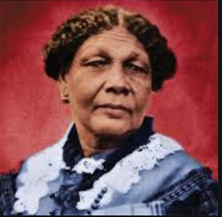
What year was I born in?

Where was I born?

Who taught me about medicine?

Where did I go to help injured soldiers?

How did I help the sick soldiers?

What name did I become known as?

What did I do when the war was ended?

